Aspects of the Vietnam War

Basically the term "Vietnam War" refers to a military struggle fought in Vietnam from 1959 to 1975, involving the North Vietnamese and the National Liberation Front (NLF) in conflict with United States forces and the South Vietnamese army. From 1946 until 1954, the Vietnamese had struggled for their independence from France during the First Indochina War. At the end of this war, the country was temporarily divided into North and South Vietnam. North Vietnam came under the control of the Vietnamese Communists who had opposed France and who aimed for a unified Vietnam under Communist rule. The South was controlled by Vietnamese who had collaborated with the French.
The United States became involved in Vietnam because it believed that if all of the country fell under a Communist government, Communism would spread throughout Southeast Asia and beyond. This belief was known as the “domino theory.” The U.S. government, therefore, supported the South Vietnamese government. This government’s repressive policies led to rebellion in the South, and the NLF was formed as an opposition group with close ties to North Vietnam.
In 1965 the United States sent in troops to prevent the South Vietnamese government from collapsing. Ultimately, however, the United States failed to achieve its goal, and in 1975 Vietnam was reunified under Communist control; in 1976 it officially became the Socialist Republic of Vietnam. During the conflict, approximately 3 to 4 million Vietnamese on both sides were killed, in addition to another 1.5 to 2 million Laotians and Cambodians who were drawn into the war. More than 58,000 Americans lost their lives.

Kennedy's role in the Vietnam War
- In 1961 South Vietnam signed the military and economic aid treaty with the United States leading to the arrival of US support troops in 1961 and the formation of the US Military Assistance Command in 1962.
- In 1963 Duong Van Minh overthrew the government of Diem because of the dissatisfaction of the population. But most soldiers arrived under Johnson's rule.
- The reasons for Kennedy's policy were the domino theory
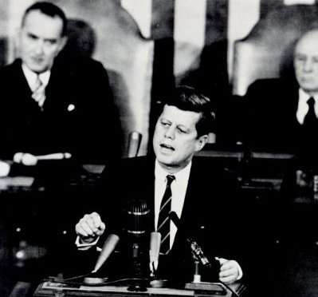
In his famous speech in Congress, Kennedy explains his point of view:

“Mr. Speaker, Mr. Vice President, my co partners in Government, gentlemen-and ladies:

The Constitution imposes upon me the obligation to "from time to time give to the Congress information of the State of the Union." While this has traditionally been interpreted as an annual affair, this tradition has been broken in extraordinary times.

These are extraordinary times. And we face an extraordinary challenge. Our strength as well as our convictions have imposed upon this nation the role of leader in freedom's cause.

No role in history could be more difficult or more important. We stand for freedom.

That is our conviction for ourselves--that is our only commitment to others. No friend, no neutral and no adversary should think otherwise. We are not against any man--or any nation--or any system--except as it is hostile to freedom. Nor am I here to present a new military doctrine, bearing any one name or aimed at any one area. I am here to promote the freedom doctrine.[...]”
Strategy in the Vietnam War

Aircraft:
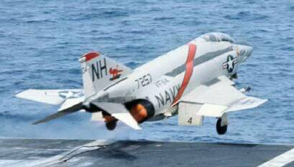
F-4 Phantom:
The F-4 Phantom, the main fighter for both the Navy and Air Force, lacked an internal gun or cannon.The Phantom relied on radar, long-range Sparrow missiles and short-range heat-seeking Sidewinders. Before Vietnam this all-missile armament was seen as quite sufficient and an internal gun obsolete. Pilots dogfighting in the skies over south-east Asia soon found the lack of a gun a real liability.

During the course of the war, F-105 aircrews downed 27½ MiGs, sharing one with a F-4D Phantom crew. 25 of those kills were achieved with the M-61 internal cannon of the Thud, two with AIM-9 Sidewinder missiles.

F-8 Crusader:

For a time, the Crusader was the leading MiG-killer over Vietnam, accounting for a total of 18 confirmed victories. All of them occurred within a two-year span (1966-1968), and after that all Navy MiG kills were by Phantoms.

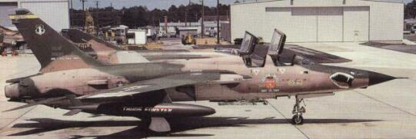
F-105 Thunderchief:
Over 20,000 combat missions were flown by Thunderchiefs in Vietnam. A total of over 350 Thunderchiefs (Ds and Fs) were lost in combat, most of them to North Vietnamese anti-aircraft fire. This was over half of all Thunderchiefs built. 126 F-105s were lost in 1966 alone, 103 of them to AAA. At one point in 1965-1968, it was calculated that a F-105 pilot stood only a 75 percent chance of surviving 100 missions over North Vietnam. Although the total number of losses was rather high, the actual loss rate was not that bad considering the total number of missions that were flown.
The Thunderchief made an excellent tactical bomber. The internal bomb bay had originally been designed with nuclear weapons in mind, but for operations in Southeast Asia, the internal bay of the F-105D rarely carried any ordnance, usually being fitted with a 365-gallon auxiliary fuel tank. With the exception of the ammunition for the M61A1 cannon, all the ordnance was carried externally. With multiple ejector racks the F-105D could carry an impressive load of external fuel, ECM gear, and up to eight 750-pound bombs on long-range missions. On short-range missions, it could carry sixteen 750-pound bombs. Alternative combat loads were two 3,000-pound bombs or three drop tanks. On a typical mission over North Vietnam, the F-105D would carry six 750-pound bombs or five 1,000-pound bombs, along with two 450 US-gallon drop tanks.

B-52 Stratofortress:
The massive B-52 Stratofortress bomber as the main bomber of Strategic Air Command was designed to fly deep into enemy territory and drop nuclear weapons. But for the Vietnam conflict modifications allowed each bomber to carry fifty-one 750 or 500 lb. conventional bombs, later increased to an incredible one-hundred and eight bombs.
The B-52 effort concentrated primarily against suspected Viet Cong targets in South Vietnam, but the Ho Chi Min Trail and targets in Laos were also hit. During the relief of Khe Sanh, unbroken waves of six aircraft, attacking every three hours, dropped bombs as close as 900ft (300 m) from friendly lines.

Weapons:

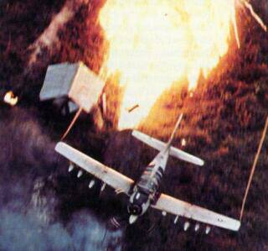
Napalm:
Although used during World War II and seeing extensive use in Korea this weapon became widely known during this conflict. It was used in massive quantities along with fuel air explosives to blast through dense jungle growth and get at enemy troops and positions.
It is estimated that the United States used a total of 338,237 tons of napalm in the Vietnam war between 1963 and 1971.

Laser-guided bombs:
Laser guided bombs are quite accurate and cause considerable damage to most targets. However, bunkers, heavily reinforced buildings and buried structures can generally withstand such attacks.

Agent Orange:

A mixture of herbicides that U.S. military forces sprayed in Vietnam from 1962 to 1971 during the Vietnam War for the dual purposes of (1) defoliating forest areas that might conceal Viet Cong and North Vietnamese forces and (2) destroying crops that might feed the enemy. The defoliant, sprayed from low-flying aircraft, is toxic even in minute quantities. About 50 million liters (13 million gallons) of Agent Orange--containing about 170 kg (375lb) of dioxin--were dropped on Vietnam. Among the Vietnamese, exposure to Agent Orange is considered to be the cause of an abnormally high incidence of miscarriages, skin diseases, cancers, birth defects, and congenital malformations (often extreme and grotesque) from the 1970s to the '90s. Many U.S., Australian, and New Zealand servicemen who suffered long exposure to Agent Orange in Vietnam later developed a number of cancers and other health disorders.

Strategy:
After a Viet Cong attack in February 1965 on U.S. Army barracks in Pleiku, the United States commenced Operation Rolling Thunder, a restricted but massive bombing campaign against North Vietnam. Protection of air bases then provided the rationale for introduction of 50,000 U.S. ground combat forces, which were soon increased.
On March 2, 1965 Operation Rolling Thunder commenced, a sustained bombing campaign intended to place increasing pressure on the North Vietnamese leadership to negotiate a peaceful settlement to the war. The idea was to strike targets just above the DMZ ( Demilitarized Zone ) and then progressively hit targets further north ( closer to Hanoi ) as the campaign went on.
The rules of engagement placed many restrictions on the armed forces. Bombing was prohibited within 25 miles (40 km) of the Chinese border, within 10 miles (16 km) of Hanoi ( the capital ) and within 4 miles ( 6.4 km ) of Haiphong ( the major port.) By placing the capital, Haiphong and surrounding areas off limits the U.S. Air Force was prevented from attacking nearly all military targets crucial to the war effort of the enemy. Additionally, much to the annoyance of Air Force generals, no enemy air bases could be attacked for fear of killing Soviet technicians.

Rolling Thunder continued from 1965 to 1968. In all, the US flies 304,000 fighter-bomber sorties and 2,380 B-52 sorties over North Vietnam, losing 922 aircraft and dropping 634,000 tons of bombs.
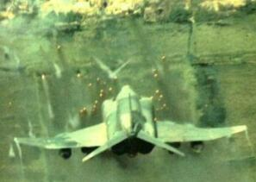
Operation Arc Light:

While some military leaders thought highly of Arc Light, many Air Force commanders thought using B-52s for tactical purposes diverted them from their principal mission of strategic deterrence. Others believed they were being used ineffectively, and simply blowing holes in the jungle.

The first raid was carried out from Guam by 27 B-52Fs on June 18, 1965 against an unseen Viet Cong target at Ben Cat, 40 miles north of Saigon. This raid was not an outstanding success, and it is not at all certain that anything of military value was actually inside the target area that was bombed. The accuracy of the bombing was less than spectacular, and only about half the bombs actually landed in the target area. In addition, a general pall was cast over the entire operation since it had cost the loss of two B-52Fs which had been destroyed in a mid-air collision on their way to the target, killing 8 crew members.

Other Actions:
The B-52’s were used extensively throughout the war to carpet bomb the Ho Chi Minh trail over widespread areas. The B-52 was one of the weapons the NVA and VC feared the most.
The air attack on the Ho Chi Minh Trail was the largest bombing effort outside Vietnam during the war. Located in Eastern Laos and Cambodia, the Ho Chi Minh trail was a series of North Vietnamese Army supply routes that American Air Force had been bombing since 1964

Navy / Marine Actions
1962 -- Thailand. The 3d Marine Expeditionary Unit landed on May 17, 1962 to support that country during the threat of Communist pressure from outside; by Jul 30 the 5000 marines had been withdrawn.
1962-75 -- Laos. From October 1962 until 1976, the United States played a role of military support in Laos.
1970 -- Cambodia. U.S. troops were ordered into Cambodia to clean out Communist sanctuaries from which Viet Cong and North Vietnamese attacked U.S and South Vietnamese forces in Vietnam. The object of this attack, which lasted from April 30 to June 30, was to ensure the continuing safe withdrawal of American forces from South Vietnam and to assist the program of Vietnamization.
1975 -- South Vietnam. On April 30 1975, President Ford reported that a force of 70 evacuation helicopters and 865 Marines had evacuated about 1,400 U.S. citizens and 5,500 third country nationals and South Vietnamese from landing zones near the U.S. Embassy in Saigon and the Tan Son Nhut Airfield.

Brutality and Cruelties during the Vietnam War

There were two victims: nature and the Vietnamese people.
The jungle was a big problem for the American military, because the Vietcong hid there.
So the Americans flew over the jungle and covered more than 10 per cent of the area of South Vietnam with a toxical herbicide cocktail

The ecological balance was disturbed by:

- 13 000 000 tons of bombs
- 72 000 000 liters of defoliants
- 2 000 000 hectars of burnt wood
- 100 000 hectars of destroyed mangroves

Among the victims were:

In South Vietnam:
- 15 000 American soldiers
- 70 000 Vietnamese
- murders of women and children

In North Vietnam:
- 230 000 dead
- rapes

» more than 3 000 000 people died.

For example, there was the fertile area of Adoui with its huge trees, elephants, tigers, monkeys and almost 150 different kinds of birds. Today this area is a dead, dry savannah with pest plant and rats and only 21 kinds of birds.

In 1967 the American bureau of defence claimed that there won't be any lasting damage.

Consequential damages

During the Vietnam War American troops sprayed roughly 72 000 000 liters of toxic herbicides out of planes and helicopters over the woods and rice plantations with the aim to weaken the resistance and to expose the ways of supply of the enemy's army. Over 40 000 000 liters of the used herbicides were very toxic, the so-called Agent Orange. It contained the most toxic substance which is known: dioxin

The country of Vietnam itself was exposed to the bombardments of the US airforce during the war: The whole economy and the infrastructure were destroyed. This resulted in massive economic problems in the postwar period. The use of napalm and defoliants have caused massive economic damages.

Where once rainforests existed with a rich fauna, there grow only grass and bushes today. The effects are erosions and massive floodings. The US claims that 14 per cent of Vietnam’s woods were destroyed by herbicides.

But the defoliant Agent Orange had a dreadful effect on people’s health.

The defoliant Agent Orange is the cause of deformities of 100 000 of people. Many years after the Vietnam War, the number of victims of this war is increasing. Roughly 500 000 Vietnamese children were born with deformities.

Even today, over 25 years after the end of war, the Vietnamese ambulance claims that over 1 000 000 people suffer from long-term consequences of the dioxin, from which 100 000 are children.
Deformities, cancer and a weak immune system are some examples of possible damages caused by dioxin, which is still circulating in the food chain.

The diseases, that are caused by dioxin toxications, are widespread. All parts of the human body are affected. With the limited knowledge and the rare technical resources the doctors are helpless. Many of the dioxin-poisoned children are looked after in so-called Agent Orange camps. But children can only stay there for some months. They get medical care and learn a trade, so they are no burden for their families.

The USA has not participated in the Agent Orange camps financially yet. It was only in 1998 that the US airforce admitted possible connections between dioxin and physical problems.

The psychological wounds of the survivors have not been healed yet. An English study says that Vietnam veterans are 86 per cent more likely to commit suicide than any other soldiers.

