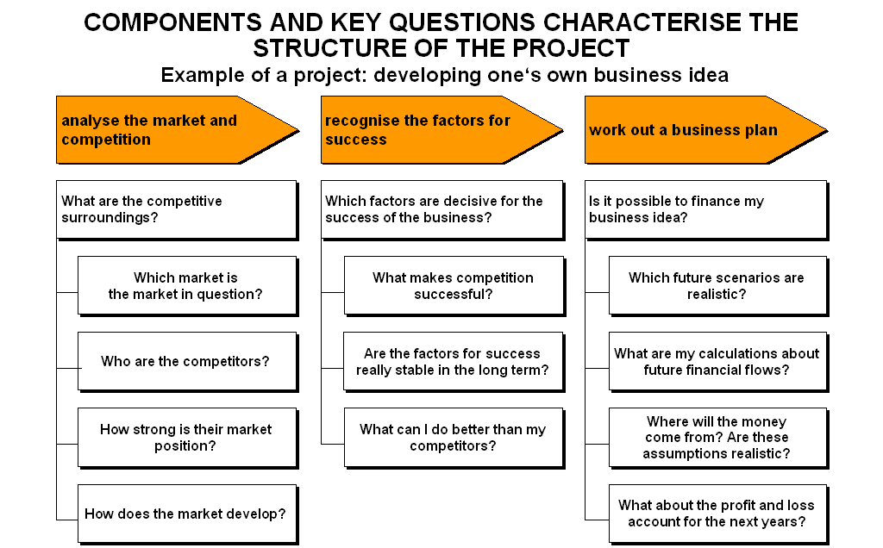

Working on your own business plan
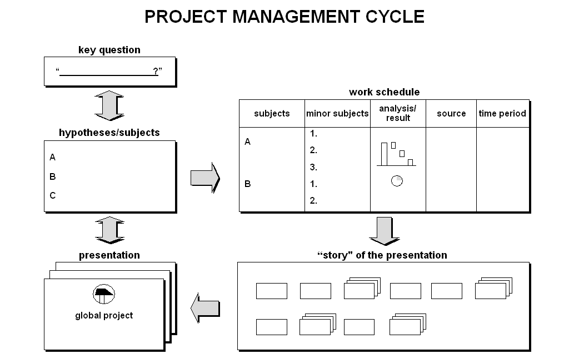
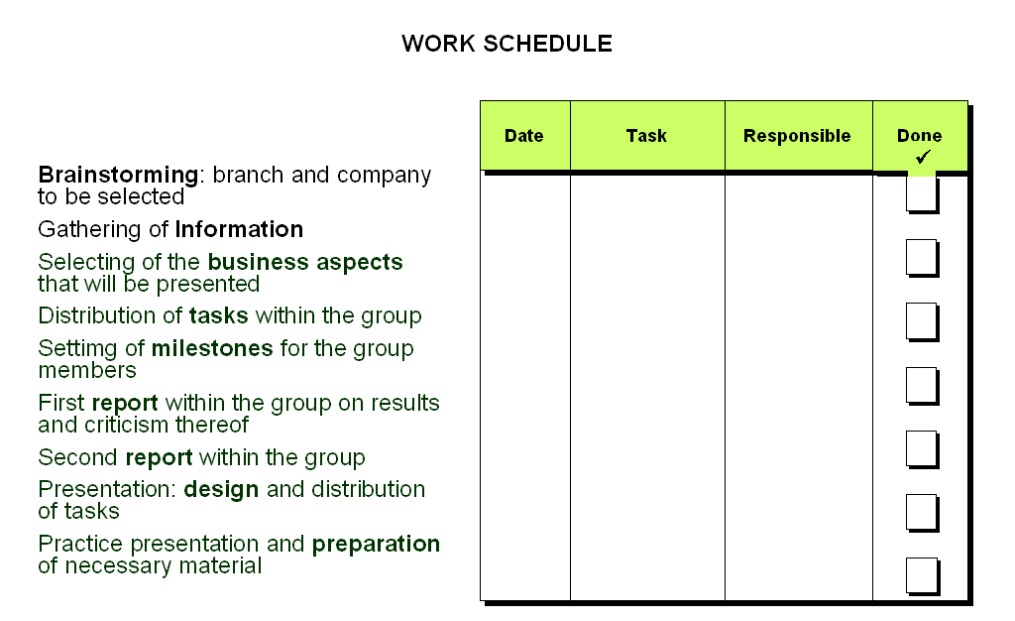

Four time management strategies

- Work faster – deal with related things at the same time
- Delegate tasks in a reasonable way – possibly delete them
- Do the right thing – establish priorities
- Use systems

Do the following tasks first:
- Tasks that need time-consuming preparation
- Tasks with high benefits compared to expenses
- Tasks that underpin or refute basic assumptions

General time management problems

- Vagueness about aim and object of the specific task
- Vague allocation of tasks to different people
- Difficulties in establishing priorities
- Waste time with details, lose sight of general perspective
- Too much or not enough focus on situation-specific details
- Alternatives are not well-considered, no substitute plans

